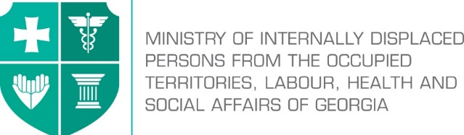

Labour Conditions Inspection Department
Create Together Safe Working Environment!

Annex №6

General Guidance Related to Infection (COVID-19) Caused by Novel Coronavirus (SARS-CoV-2) for Transport Sector

Note: In accordance with Order N281/N of the Minster of Internally Displaced Persons from the Occupied Territories, Labour, Health and Social Affairs of Georgia on “the rule for Examination for Short-term Employment Disability and Issuance of Doctors Note”, the Ministry of Internally Displaced Persons from the Occupied Territories, Labour, Health and Social Affairs of Georgia will issue an equivalent document to the doctors excuse note (Medical Certificate) to persons quarantined in order to prevent the spread of coronavirus. The document will serve as the basis to receive monthly payment and therefore, the working days spend in quarantine or in self-isolation will be legitimate and fully paid to the employees. In order to get the certificate, an interested person has to apply to the Ministry of Internally Displaced Persons from the Occupied Territories, Labour, Health and Social Affairs of Georgia at - info@moh.gov.ge.


The staff must not appear in the workplace if they:
- Left the affected country over the past 14 days;
- Were in close contact with infected person/persons for the past 14 days (they must be self-isolated/quarantined as per the rule);
- Have symptoms of respiratory infection (coughing, temperature, sneezing, difficulty in breathing, general weakness etc.);
- Are among the ones who have high risk of getting infected with COVID-19 or serious complications: over 70 years of age, people suffering from chronicle diseases (cardio-vascular diseases, diabetes, bronchial asthma and other respiratory diseases.

Employer’s responsibilities
- Before starting work performance employees health condition should be controlled;
- Whether or not the incidence of infection is detected, should develop an emergency action plan to support reduction of working days missed due to illness, and in case of detection – prevention of spread;
- Provide the employees with appropriate personal protective equipment (respirator, if needed gloves, face shield and relevant glasses);
- Inside vehicles post announcements (if available on monitors) about COVID-19 and about the preventive measures that have been identified by LEPL L. Sakvarelidze National Center for Disease Control and Public Health of the Ministry of Internally Displaced Persons from the Occupied Territories, Labour, Health and Social Affairs of Georgia;
- Provide all the employees and personnel responsible for cleaning with information about relevant prevention procedures to avoid spread of coronavirus within the working environment;
- Provide hand-washing facility for staff, with soap and other disinfectants. If hand-washing facility is not feasible, at least 70% alcohol-based hand cleansing liquid should be used;
- Train the staff in proper use and further storage/removal of personal protective equipment and disinfectants;
- Make sure that employees have access to hand disinfectants and are aware of their proper use;
- Visibly post the rules of proper use of hand disinfectants;
- Periodically, several times a day, ensure natural ventilation of closed spaces;
- At certain periodicities disinfect frequently used working equipment and working places, sanitation of appliances inside the vehicles after each performed route;
- Ensure placement of closed containers for disposable tissues used by employers and passengers and other hygienic waste;
- Ensure timely disposal of used disinfectants by relevant person/service;
- Arrange temporary protective transparent barrier at the driver’s cabin;
- Develop the policy and procedures for immediate isolation of persons who have signs and/or symptoms of COVID-19 and train the staff in their implementation.

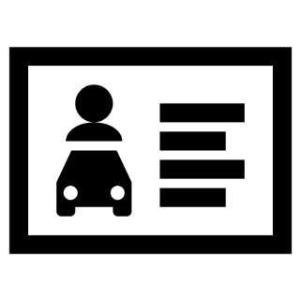
Employees’ responsibilities
Ensuring proper hand hygiene regularly and thoroughly is the best way to be protected from most of the viruses. Therefore, it is necessary to take the following measures in the workplace:
- Follow disinfection rules in your workplace;
- Carry out the working process in accordance with emergency situations action plan defined by employer/occupational safety manager;
- While performing your work, fully use personal protective equipment provided by the employers;
- Before starting your work and in the course of the work use disinfectants for cleaning the working places and tools;
- Before and after taking meals, before and after using the restrooms thoroughly wash your hands with soap and water;
- Use alcohol-based hand sanitizers and if you cannot wash or dry your hands;
- Keep safe distance (at least 2 m);

- When coughing and sneezing cover the face with a clean tissue or elbow. Place used dispensable tissue in the waste bin;
- Avoid touching your eyes, nose and mouth with hands.

